Order Of Service

Singing: Psalm 67—CW page 91

Reading: Psalm 80

Opening Hymn: CW 50

Reading: Acts 13:13-33

Request Hymn: CW Supplement 748

Reading: Matthew 2:1-12

Sermon Hymn: CW 363

Sermon Text: Mark 1:12-13

With The Wild Beasts

Prayer

The Apostles’ Creed, TLH page 12

Holy Communion

The Lord's Prayer

The Blessing

Closing Hymn: CW 260

* * * * * * * * * * *

Bible Study: Lambs: Orchid
Sheep: Romans 15:22-33
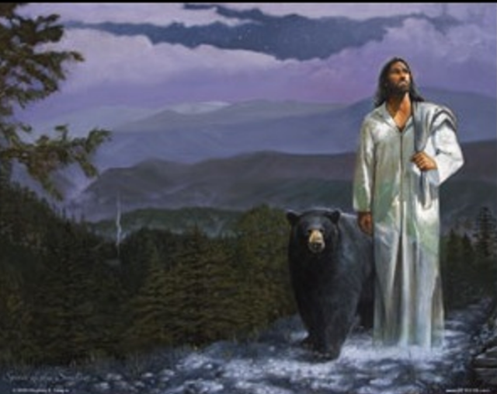

With The Wild Beasts

Water
Of
Life

23 September 2018

W A T E R O F L I F E

Independent Christian Church—Conservative Lutheran Doctrine

Worship Service: 9:30 a.m. Bible Study: 10:45 a.m.

Larry Cooper, Pastor E-Mail address:
111 N. Ridge Road lcooper@wateroflife.cc
Coon Valley, WI 54623 Web Site:
Phone: (608) 452-2105 www.wateroflife.cc

* * * * * * * * * * * * * * * * * * * * * * * * * * *

Sermon Text: Mark 1:12-13

With The Wild Beasts

* * * * * * * * * * * * * * * * * * * * * * * * * * *

Mark 1:12 And immediately the Spirit driveth him into the wilderness.
:13 And he was there in the wilderness forty days, tempted of Satan; and was with the wild beasts; and the angels ministered unto him.

Also recorded in Matthew 4:1-11 and Luke 4:1-13

Matthew 4:1 Then was Jesus led up of the Spirit into the wilderness to be tempted of the devil.
:2 And when he had fasted forty days and forty nights, he was afterward an hungred.

:3 And when the tempter came to him, he said, If thou be the Son of God, command that these stones be made bread.
:4 But he answered and said, It is written, Man shall not live by bread alone, but by every word that proceedeth out of the mouth of God.
:5 Then the devil taketh him up into the holy city, and setteth him on a pinnacle of the temple,
:6 And saith unto him, If thou be the Son of God, cast thyself down: for it is written, He shall give his angels charge concerning thee: and in their hands they shall bear thee up, lest at any time thou dash thy foot against a stone.
:7 Jesus said unto him, It is written again, Thou shalt not tempt the Lord thy God.
:8 Again, the devil taketh him up into an exceeding high mountain, and sheweth him all the kingdoms of the world, and the glory of them;
:9 And saith unto him, All these things will I give thee, if thou wilt fall down and worship me.
:10 Then saith Jesus unto him, Get thee hence, Satan: for it is written, Thou shalt worship the Lord thy God, and him only shalt thou serve.
:11 Then the devil leaveth him, and, behold, angels came and ministered unto him.

